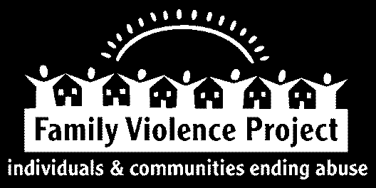
Family Violence Project (FVP) is working to end domestic violence in Kennebec and Somerset counties in Maine. We believe it will take the whole community to accomplish our mission. This includes a strong and committed work force.

If you are seeking a challenging position in a critical field of advocacy and social justice, please consider the following open position:

Prevention Educator, Northern Kennebec and Somerset Counties — Full Time
Family Violence Project seeks an individual to provide education, training, presentations, individual advocacy and other activities to schools, community groups, and other venues. The focus of the Prevention Educator’s work will be on domestic violence, dating violence, human trafficking, and stalking, particularly but not exclusively as it relates to youth, including those who identify as LGBTQ. This is a full time (37.5 hour per week) position that includes occasional on-call responsibilities and may include evenings and weekends. This position will be based out of our Skowhegan office. Excellent benefits including health insurance, paid time off, short and long term disability, and retirement plan are available. The goal of this position is to decrease risk-factors of domestic violence and promote healthy relationships with youth, youth organizations, parents, community organizations and coalitions. The yearly pay range for this position is $31,200 to $46,800.
The successful candidate will possess knowledge of and passion for issues related to domestic violence and social change advocacy. This person must be well-organized with demonstrated skills and experience with scheduling, coordinating and delivering presentations, facilitating groups, using social media and networking. This candidate is comfortable working with diverse groups of people to energize populations and effect change in systems. Our ideal candidate will have excellent communication and interpersonal skills and be dynamic, creative and engaging in presentations. Effective listening, oral, written, and computer skills are necessary. A bachelor’s degree in social work, human services or education is preferred. Successful completion of Family Violence Project’s Crisis Advocacy, Intervention, Response and Ethics Training for New Advocates is required upon hire.
EOE
Mail cover letter and resume by March 5th, 2020 to:
Search Committee, Prevention Educator
Family Violence Project, PO Box 304, Augusta, ME 04332-0304
Or email required application materials to jmooney@familyviolenceproject.org
Resumes without cover letters will not be considered.

