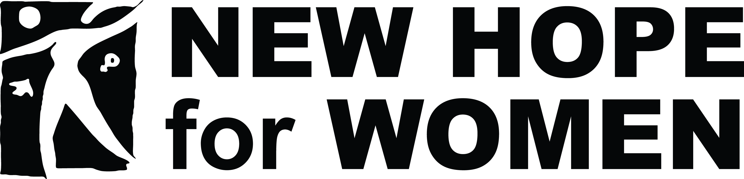

Exciting opportunity to be a part of a dynamic community organization committed to improving the lives of those we serve. New Hope for Women is a domestic violence resource center that offers support to people in Sagadahoc, Lincoln, Knox, and Waldo counties affected by domestic violence, dating violence, and stalking. We also provide educational resources to assist our communities in creating a safer, healthier future.
We currently have an opening for a Community and Legal Advocate in our Rockland office. The Community and Legal Advocate is responsible for providing direct services such as crisis intervention, support group facilitation, legal advocacy, information and referrals to victims of domestic abuse in Knox County.

- We seek a candidate with effective listening, oral and written communication skills
- Experience working with adults
- Group facilitation skills and experience
- Knowledge of local social service, criminal justice, and health systems
- Organized, with strong attention to detail and a structured way of approaching tasks
- Comfortable working independently, with limited day-to-day supervision
- Punctual, dependable, and committed to the work
- Respectful, kind, and empathetic
- Basic computer skills (working knowledge of Microsoft and Google Suites helpful but not required)
Qualifications
- Relevant bachelor’s degree, or equivalent combination of education and experience
- Possession of a valid and active Maine driver’s license, a reliable vehicle, and adequate insurance, or access to reliable transportation
Additional Job Information:
- Full-time (40 hr) position located in Rockland, ME office
- Competitive salary with excellent benefits
How to apply:
Interested candidates should submit a current resume and cover letter to: hiringcommittee@newhopeforwomen.org Please add “Community and Legal Advocate” to the subject field.
We strongly encourage those with the following identities to apply: Black, Indigenous, and people of color, people with intersecting identities - LGBTQIA+, women and non-binary people, people living with disabilities and others with lived experience being part of marginalized communities.
Closing date for this posting is 9am on August 17, 2020.

