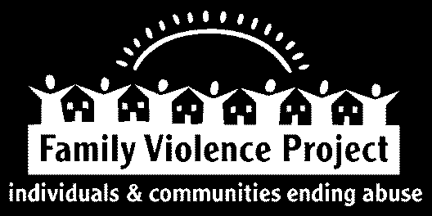
Family Violence Project (FVP) is working to end domestic violence in Kennebec and Somerset counties in Maine. We believe it will take the whole community to accomplish our mission. This includes a strong and committed work force.

If you are seeking a challenging position in a critical field of advocacy and social justice, please consider the following open position:

Shelter Advocate — Full Time
Family Violence Project seeks an advocate to provide direct services to residents of our Kennebec County emergency domestic violence shelter. This is a full time (37.5 hours per week) position with a Monday through Friday, 10am to 6pm schedule that will include occasional on-call responsibilities and may include some evenings and weekends. This position will be based out of our Kennebec County Shelter. Excellent benefits including health insurance, paid time off, short and long-term disability, and a retirement plan are available. The starting pay range for this position is $31,200 to $35,100 annually, based on experience.
The successful candidate will possess knowledge of domestic violence and its impact on victims and the community, as well as on child development. Excellent listening, oral, and written communication skills are imperative. Demonstrated skills and experience in trauma informed advocacy, conflict resolution, crisis intervention, and group facilitation are necessary. The successful candidate will be well-organized, self-directed, and a skilled problem solver. This person must communicate effectively with co-workers and the public. Experience in residential services (including basic and routine facility maintenance), mental health or substance abuse is preferred. A minimum of a Bachelor’s Degree with a specialization in psychology, mental health and human services, behavioral health, behavioral sciences, social work, human development, special education, counseling, rehabilitation, sociology, nursing or closely related field, or a Bachelor’s Degree in an unrelated field and at least one (1) year of full-time equivalent relevant human services experience is required for this position. Successful completion of CAIRET (Crisis Advocacy, Intervention, Response and Ethics Training for New Advocates) is required prior to or upon entering this position.
EOE

Provide resume and cover letter by December 9th to:
Search Committee, Kennebec Shelter Family Violence Project PO Box 304, Augusta, ME 04332-0304
or jmooney@familyviolenceproject.org

RESUMES WITHOUT COVER LETTERS WILL NOT BE CONSIDERED

